YEAR 7 SCIENCE
Chemistry End of Topic Test

NAME: Mark: /40

Select the best answer for the following questions and circle your answer clearly in the table provided.

 | Circle the correct answer
1 | A B C D
2 | A B C D
3 | A B C D
4 | A B C D
5 | A B C D
6 | A B C D
7 | A B C D
8 | A B C D
9 | A B C D
10 | A B C D
1. Which of the following can a sieve not be used for?

(a) separating solids and liquids.
(b) separating solutes and solvents
(c) separating solids of different sizes
(d) it can be used for all of the above.

2. Milk is a mixture of fat mixed through water. The fat does not settle out easily. Milk is an example of:

(a) a solution.
(b) a suspension
(c) a colloid
(d) a solute

3. The process used in the diagram to the right is called:
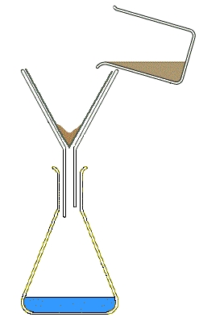

(a) filtration.
(b) evaporation.
(c) decantation.
(d) boiling.

4. A substance is insoluble in a solvent if:

(a) it will not dissolve in the solvent.
(b) there is too much solid to dissolve.
(c) it will not dissolve in water.
(d) it is an oily substance.

5. The contents of a test tube had the following characteristics:

- Light could not pass through it
- When left untouched for a long time sediment appeared on the bottom

What is contained in the test tube?

(a) A solution
(b) A solid
(c) A suspension
(d) There is not enough information to determine the contents

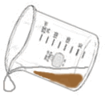
6. The process used in the diagram to the right is called:

(a) filtration.
(b) evaporation.
(c) decanting.
(d) boiling.

7. The best method of separating sand and rice would be:
(a) filtration.
(b) evaporation.
(c) decanting.
(d) sieving.

8. To separate sand and water you could use:

(a) filtration.
(b) evaporation.
(c) decanting.
(d) any of the above

9. Which of the following is not a type of mixture:

(a) suspension
(b) colloid
(c) solvent
(d) solution

10. Which of the following is a method for separating soluble substances?

(a) filtration.
(b) evaporation.
(c) decanting.
(d) centrifuging.

Short Answer Write the answer to the questions in the spaces provided.

If you run out of space or make a big mistake you can use the back page to rewrite your answer

1. Describe how you would fold a piece of filter paper in a conical shape (1)
You may use a diagram if you wish

_______________________________________________________________________________________________________________________________
_______________________________________________________________________________________________________________________________

2. Explain how filter paper works. (2)

_________________________________________________________________________________________________________________________________
__________________________________________________________________________________________________________________________________________________________________________________________________________________________________________________________________

3. a) Label where you would find the following on the diagram below: (2)
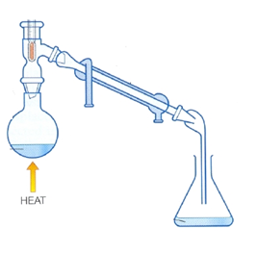
Condensation
Evaporation
Boiling
Solution

b) What method of separation is being carried out by the equipment above? (1)

_______________________________________________________________________________________________________________________________

c) Explain how the equipment shown above could be used for desalination. (3)

_________________________________________________________________________________________________________________________________
___________________________________________________________________________________________________________________________________________________________________________________________________________________________________________________________________________________________________________________________________________________________________________________________________

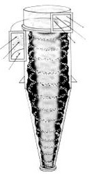
5. a) The diagram to the right shows a tube in which air and dust is spinning very fast. Dusty air is sucked into the tube and clean air is forced out. The dust settles to the bottom. What method of separation is being used here? (1)
_____________________________________________________________________________________________________

b) Name another piece of equipment that uses this same method of separation. (1)

_____________________________________________________________________________________________________

6. Beaker A and Beaker B both contain 100ml of water. One spoon of sugar was added to Beaker A, while 2 spoons of sugar was added to beaker B. (5)

a) What is the solute in this question? _____________________________________

b) What is the solvent? _____________________________________

c) In which beaker would you find a solution? _____________________________________

d) Which beaker contains the more concentrated solution? _____________________________________

e) What would happen to beaker B if you kept adding more sugar?
__________________________________________________________________________________________________________________________________________________________________________________________________________________________________________________________________

7. a) One of the test tubes below contains a solution, the other a suspension. Label them correctly. (2)

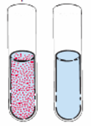

b) Which one of these could be separated using a filter, or could both? (1)
_____________________________________________________________________________________________________________________

8. Describe one separation technique that is, or could be, used to produce pure water for drinking. (3)

_______________________________________________________________________________________________________________________________________________________________________________________________________________________________________________________________________________________________________________________________________________________________________________________________________________________________________________________________________________________________________________________________________________________________________________________________________________________________________________________________________________________________________________________________________________________________________________________________________________________________________________________________________________________________________________________________________

9. If you were given a mixture of sand and salt describe how you would separate it and still retain both the sand and the salt. Use dot points or steps. (3)

_______________________________________________________________________________________________________________________________________________________________________________________________________________________________________________________________________________________________________________________________________________________________________________________________________________________________________________________________________________________________________________________________________________________________________________________________________________________________________________________________________________________________________________________________________________________________________________________________________________________________________________________________________________________________________________________________________

10. a) On the diagram below label the solute and the solvent. (2)
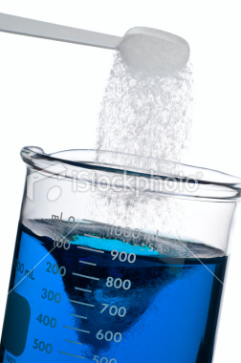

b) How could you make the solution more concentrated? (1)
__________________________________________________________________________________________________________________________________________________________________________________________________________________________________________________________________

C) What would eventually happen if more and more sugar was added to the beaker? (2)

_________________________________________________________________________________________________________________________________

_________________________________________________________________________________________________________________________________

_________________________________________________________________________________________________________________________________

